Lab 06: Deciphering File Formats

CYBR 688: Software Reverse Engineering

Team Members: Sairam Bokka, Ethan Hart

Introduction:
In this lab, we will exploit a server containing a memory disclosure vulnerability. Its purpose is to protect a secret message shared only with those knowing the login credentials. An authenticated user may get and set the secret message but the memory disclosure vulnerability may help us find credentials and find the secret.

Materials:
-Licensed copy of Linux (Ubuntu Virtual Machine used for this lab)
-Ghidra suite for dynamic analysis
-Python3 installed on your machine
-Vulnerable server binary
-Client-side API and functional test

Understanding the test client and vulnerable server binary:
- For understanding the vulnerable server, we will run the server and run test_client.py file which connects to the server and performs a few tests on the server.
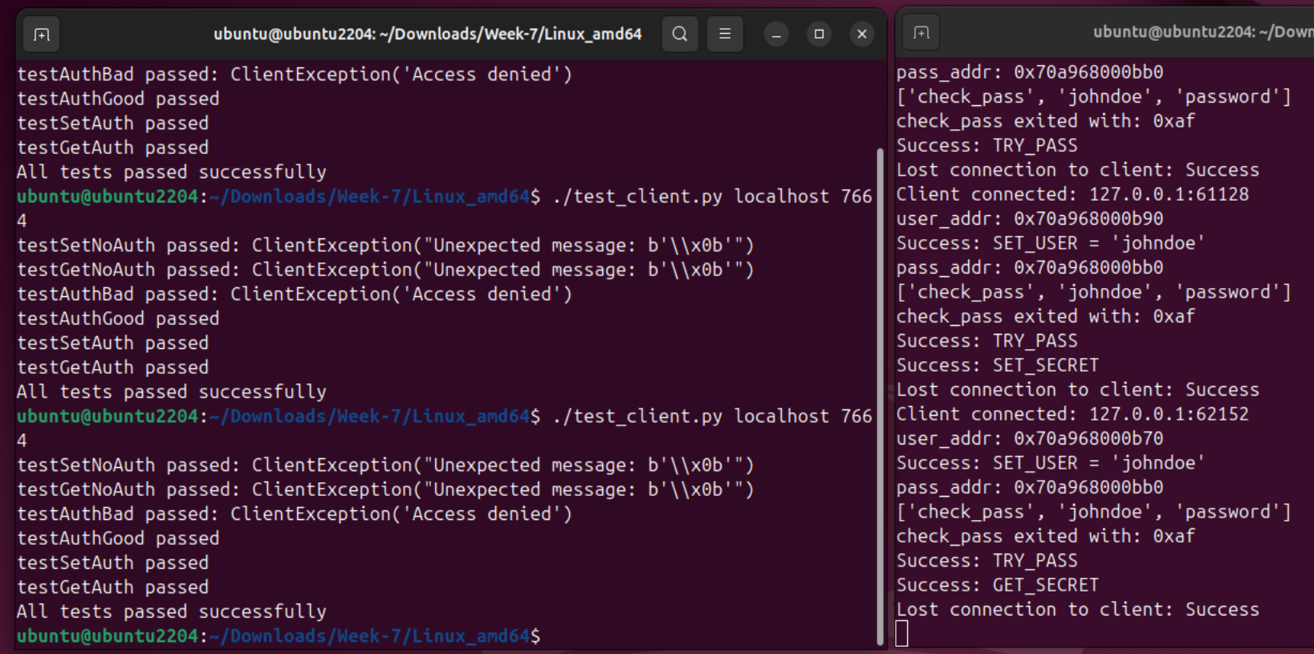
- As we can see in the figure, the test client performs a few authentication tests on the server which were completed successfully.
- The server prints out debug information about the connections made by the client and functions used by the client in the server. In this case, it is using SET_USER, GET_USER, TRY_PASS, SET_SECRET, GET_SECRET. It prints out addresses of username and password. It also invoks a sub process called check_pass, which it might be using to check the username and password provided to the server.
Protocol Documentation
The protocol uses specific message types with byte structures to manage user authentication and secret handling. All messages have a predefined structure with fields like size, username, password, and secret. Messages are exchanged in Little-Endian (LE) format for multi-byte values.

Commands
1. SET_USER
- Purpose: Set the username on the server.
- Direction: Client → Server (C → S)
- Structure:
  - type: 0
  - length: 2 bytes (LE) indicating the length of username.
  - username: Variable-length UTF-8 string.
- Response:
  - Direction: Server → Client (S → C)
  - type: 6 (Echoed)
  - username: The same username as provided by the client.

2. TRY_PASS
- Purpose: Attempt to authenticate with a password.
- Direction: Client → Server (C → S)
- Structure:
  - type: 2
  - length: 2 bytes (LE) indicating the length of password.
  - password: Variable-length UTF-8 string.
- Responses:
  - If Password is Correct:
    - Direction: Server → Client (S → C)
    - type: 8 (Access Granted)
  - If Password is Incorrect:
    - Direction: Server → Client (S → C)
    - type: 7 (Access Denied, Disconnect)

3. SET_SECRET
- Purpose: Set a secret on the server.
- Direction: Client → Server (C → S)
- Structure:
  - type: 3
  - size: 2 bytes (LE) indicating the size of secret.
  - secret: Variable-length data.
- Response:
  - Direction: Server → Client (S → C)
  - type: 9 (Acknowledgment)

4. GET_SECRET
- Purpose: Retrieve the previously set secret.
- Direction: Client → Server (C → S)
- Structure:
  - type: 4
  - size: 2 bytes (LE) indicating the size of the expected secret.
- Response:
  - Direction: Server → Client (S → C)
  - type: 10
  - secret: Variable-length data as set by the SET_SECRET command.

5. GET_USER
- Purpose: Retrieve the current username.
- Direction: Client → Server (C → S)
- Structure:
  - type: 1
  - Note: The message structure for GET_USER is currently unknown based on available information.
- Responses:
  - If SET_USER has not been called:
    - Direction: Server → Client (S → C)
    - type: 11 (Cannot GET_USER before SET_USER)
  - If SET_USER has been called:
    - Direction: Server → Client (S → C)
    - type: 6 (Same response as SET_USER, with echoed username)

Command | Direction | Type | Description
SET_USER | C -> S | 0 | Set Username
 | S -> C | 6 | Echo Username
TRY_PASS | C -> S | 2 | Attempt password authentication
 | S -> C | 8 | Access granted
 | S -> C | 7 | Access Denied, Disconnect
SET_SECRET | C -> S | 3 | Set a secret
 | S -> C | 9 | Acknowledgement
GET_SECRET | C -> S | 4 | Request a secret
 | S -> C | 10 | Provide a secret
GET_USER | C -> S | 1 | Request username
 | S -> C | 11 | Error if SET_USER not called
 | S -> C | 6 | Echo Username if SET_USER called

Procedure:

